Adaptive Cognitive-Load Study Timer for Personalized Break Scheduling

Rajendram P. A.
(IT22087874)

BSc. (Hons) Degree in Information Technology Specializing in
Software Engineering

Department of Software Engineering

Sri Lanka Institute of Information Technology, Sri Lanka

April 2026
DECLARATION OF THE CANDIDATE AND SUPERVISOR

I declare that this is my own work and this proposal does not incorporate without acknowledgment any material previously submitted for a degree or diploma in any other university or Institute of higher learning and to the best of my knowledge and belief it does not contain any material previously published or written by another person except where the acknowledgment is made in the text.

Name | Student ID | Signature
Rajendram P. A. | IT22087874

The supervisor/s should certify the proposal report with the following declaration.

The above candidate is carrying out research for the undergraduate Dissertation under my supervision.

…………………………….. | ……………………
Signature of the supervisor: | Date
…………………………….. | ……………………
Signature of the co-supervisor: | Date

ABSTRACT

Maintaining focus during study sessions is a persistent challenge for students, often disrupted by impulsive task switching and premature session exits. Existing productivity tools typically rely on static timers or rigid restrictions, failing to distinguish between genuine task completion and distraction-driven behavior. This limitation results in either reduced effectiveness or poor user experience.
This study introduces Intent-Lock, an adaptive system designed to detect and manage impulsive exit behavior during study sessions. The system leverages contextual information, including session duration and cognitive load (represented as a latent mean), to classify exit attempts using a machine learning model. Based on this classification, the system applies graduated, non-intrusive interventions through an overlay interface. These interventions range from gentle reminders to reflective prompts, encouraging users to reconsider impulsive actions without restricting autonomy.
Due to the absence of real-world data, a synthetic data generation approach was used to train and validate the initial model. The system is implemented using a FastAPI backend integrated with a Next.js frontend, demonstrating real-time prediction and adaptive response capabilities.
The proposed approach contributes to the field of intelligent productivity systems by introducing exit intent as a measurable behavioral signal and applying adaptive friction as an alternative to rigid control mechanisms. Preliminary results indicate that the system can effectively differentiate exit types and provide meaningful, user-centered interventions. Future work will focus on incorporating real user data, refining the model, and conducting comprehensive user evaluations.

ACKNOWLEDGEMENT

I would like to express my sincere gratitude to my supervisor, Dr. Kalpani, for her continuous guidance, support, and valuable feedback throughout the development of this research project. Her insights and direction have played a significant role in shaping this work.
I would also like to extend my appreciation to my co-supervisor Mr.Eishan, for their support, constructive suggestions, and encouragement during this research. Their input has been valuable in refining both the technical and research aspects of the project.
I am thankful to the academic staff and the department for providing the necessary resources and a conducive learning environment to successfully carry out this project.
My appreciation also goes to my group members for their collaboration and support, particularly in integrating the different components of the overall system. Their discussions and contributions have helped improve the quality of this work.

Table of Contents
ABSTRACT 3
ACKNOWLEDGEMENT 4
List of Tables 6
List of Figures 7
Figure 2.1.3.1 Contxual Algorithm Architecture.................................................................. 20 7
Figure 2.1.3.1 How ensemble Boosting Works.................................................................... 21 7
Figure 2.2.1 Comparison of machine learning approaches for recommendation system.. 23 7
Figure 2.2.2.3.1 system diagram of cronotype predicter component………………………... 25 7
1. INTRODUCTION 8
1.1 Background and Literature Survey 8
1.2. Research Gap 11
1.3 Research Problem 12
1.4 Reseach Objectives 13
2. METHADOLOGY 17
2.2 Methodology 22
2.2.1. Overall System Description 23
2.2.1.1. System Architecture 23
8 REFERENCES 41

List of Tables

Table 1-1 example table .................................................................................................. 1

List of Figures

Figure 2.1.3.1 Contxual Algorithm Architecture.................................................................. 20

Figure 2.1.3.1 How ensemble Boosting Works.................................................................... 21

Figure 2.2.1 Comparison of machine learning approaches for recommendation system.. 23

Figure 2.2.2.3.1 system diagram of cronotype predicter component………………………... 25

1. INTRODUCTION
In today’s digital learning environment, maintaining focus during study sessions has become increasingly difficult. Students are frequently interrupted by distractions, leading to impulsive task switching and reduced productivity. While various productivity tools such as Pomodoro timers and focus applications exist, they often rely on fixed time intervals and do not account for the reasons behind a user’s behavior.
One common issue observed is that users tend to exit study sessions prematurely, not because they have completed their tasks, but due to momentary distractions or cognitive fatigue. Existing systems fail to differentiate between genuine exits and impulsive ones, treating all exit actions uniformly.
To address this limitation, this study introduces Intent-Lock, an adaptive system designed to detect exit intents and apply intelligent, non-intrusive interventions. By leveraging contextual information and cognitive load indicators, the system aims to reduce impulsive behavior while preserving user autonomy. The proposed solution focuses on creating a balance between maintaining productivity and avoiding user frustration through adaptive, gradual interaction design.

Background and Literature Survey

Maintaining sustained attention during study sessions has become increasingly challenging in modern digital environments. Students are frequently exposed to distractions such as social media, notifications, and multitasking demands, which often lead to premature task switching and reduced productivity. A common behavioral pattern observed in such contexts is the tendency to exit study sessions impulsively, driven by momentary discomfort, fatigue, or distraction rather than intentional task completion.
Traditional productivity approaches, such as the Pomodoro Technique, attempt to structure work using fixed intervals of focused activity followed by breaks. While this method is widely adopted, it assumes uniform productivity patterns across users and does not adapt to individual cognitive states. Research suggests that rigid scheduling techniques may not effectively accommodate variations in attention and fatigue, thereby limiting their real-world effectiveness [1].
To address these limitations, several digital productivity applications such as Forest and Focus Booster have been developed. These tools introduce gamification and visual progress tracking to motivate users. However, they primarily rely on external motivation and lack intelligent mechanisms to understand user intent. Importantly, these systems do not differentiate between genuine task completion and impulsive exits, treating all user actions uniformly [2].
Understanding cognitive processes is essential when addressing user behavior. Cognitive Load Theory explains how mental effort affects performance and decision-making. When cognitive load is high, users are more likely to experience fatigue and reduced self-control, increasing the likelihood of impulsive actions such as abandoning tasks prematurely. Integrating cognitive load into adaptive systems has been shown to enhance personalization and improve learning outcomes [3].
Behavioral science further supports the use of subtle interventions to influence user actions. The concept of nudging suggests that small, well-timed prompts can guide individuals toward better decisions without restricting their freedom. Systems that apply gradual, non-intrusive interventions have been found to achieve higher user acceptance compared to rigid control mechanisms, making them suitable for productivity applications [4].
Recent advancements in machine learning enable systems to model and predict user behavior using contextual data. Classification models such as logistic regression are widely used for binary decision-making tasks and are valued for their interpretability and efficiency with limited datasets. These models allow systems to move beyond static rules and respond dynamically to user behavior [5].
Despite these advancements, existing productivity tools lack integration between behavioral modeling, cognitive load awareness, and adaptive intervention strategies. Current systems do not distinguish between impulsive and genuine exits, nor do they provide context-aware responses. This highlights a significant research gap, which this study aims to address by introducing an intelligent system that detects exit intent and applies adaptive, user-centered interventions.

1.2. Research Gap

Existing study timer applications and productivity tools primarily rely on fixed time intervals and simple interaction mechanisms to support user focus. While such systems provide basic structure for managing study sessions, they lack adaptability and do not account for individual differences in attention, fatigue, or cognitive state. As a result, they are limited in their ability to effectively prevent distraction-driven behavior.
Prior research indicates that traditional time management techniques, including fixed-interval approaches, do not adequately address dynamic variations in user attention and performance [1]. Similarly, studies on gamified productivity applications show that while these tools can improve user engagement, they do not address underlying behavioral issues such as impulsive task switching and premature session termination [2]. These systems continue to treat all user exits in the same manner, without distinguishing between intentional and impulsive actions.
From a cognitive perspective, mental workload significantly influences decision-making and self-control. Cognitive Load Theory explains that high cognitive load can lead to fatigue and increased likelihood of impulsive behavior, such as abandoning tasks prematurely [3]. However, existing study timer applications do not incorporate cognitive load or any form of mental state awareness into their functionality, limiting their ability to respond to real-time user conditions.
In addition, behavioral research suggests that subtle, non-intrusive interventions can effectively guide user actions while preserving autonomy [4]. Despite this, current productivity tools either allow unrestricted exits or apply rigid constraints, neither of which provides a balanced or user-centered solution. This lack of adaptive intervention fails to address the behavioral nature of distraction.
Furthermore, studies on digital interruptions demonstrate that task switching and distractions significantly reduce productivity and increase cognitive strain [5]. However, current systems treat exit actions as simple user commands rather than meaningful behavioral signals that can be analyzed and used for intelligent intervention.
Based on these limitations, there is a clear gap in existing study timer applications. Current systems do not distinguish between impulsive and genuine exits, do not integrate cognitive load into decision-making, and do not provide adaptive, context-aware interventions. There is also a lack of approaches that treat exit behavior as a measurable signal for improving productivity.
This highlights the need for an intelligent system that can detect user intent, incorporate cognitive context, and apply adaptive, non-intrusive interventions. The proposed Intent-Lock system addresses this gap by introducing exit intent classification and gradual friction, enabling a more personalized and effective approach to maintaining user focus while preserving user autonomy.

1.3 Research Problem

Students frequently struggle to maintain consistent focus during study sessions due to impulsive task switching and distraction-driven behavior. In many cases, users exit study sessions prematurely, not because they have completed their intended tasks, but due to temporary discomfort, fatigue, or external distractions. This behavior negatively impacts productivity, learning efficiency, and time management.
Existing study timer and productivity applications, such as Pomodoro-based systems and focus tools, rely on fixed time intervals and static interaction models. These systems do not distinguish between impulsive exits and genuine task completion, treating all exit actions uniformly. As a result, users are either allowed to exit freely, leading to frequent interruptions, or are restricted through rigid controls that can cause frustration and reduce usability.
Furthermore, current systems do not incorporate contextual or cognitive factors, such as mental workload or user engagement levels, into their decision-making processes. Without considering these factors, productivity tools are unable to adapt to dynamic changes in user behavior or provide meaningful, personalized interventions.
Another key limitation is the absence of mechanisms that treat exit behavior as a measurable signal. Existing tools do not analyze exit patterns or use them to improve system responses, resulting in missed opportunities for intelligent behavior modeling and adaptive support.
Therefore, the core research problem addressed in this study is the lack of an intelligent, user-centered system that can distinguish between impulsive and genuine exits in real time and apply adaptive, non-intrusive interventions. The challenge lies in designing a system that balances behavioral guidance with user autonomy, ensuring that focus is improved without imposing restrictive or disruptive controls.

1.4 Reseach Objectives

1.4.1 Main Objectives

The main objective of this research component is to design and develop an intelligent exit-intent detection and adaptive intervention system that identifies impulsive user behavior during study sessions and applies gradual, non-intrusive friction mechanisms. The system aims to improve user focus and productivity by integrating behavioral data and cognitive load indicators to provide real-time, context-aware responses while preserving user autonomy.
    - Specific Objectives

- Exit Intent Classification Module

To develop a machine learning model that classifies user exit attempts as either impulsive or genuine based on contextual inputs such as session duration and cognitive load (latent mean).

- Cognitive Load Integration Module

To incorporate cognitive load (latent mean) as a key input feature in the system, enabling more accurate understanding of user mental state during study sessions.

- Gradual Friction Mechanism Module

To implement a multi-level adaptive intervention system that progressively increases friction, starting from gentle reminders to more interactive prompts when repeated impulsive behavior is detected.

- Overlay-Based User Interface Module

To design a lightweight overlay interface that activates during exit attempts, ensuring minimal disruption while effectively delivering interventions.
- Synthetic Data Generation Module

Generating realistic synthetic datasets based on behavioral assumptions for training and testing the machine learning model in the absence of real-world data.

- Real-Time Prediction API Module

To develop backend APIs that process user input and provide real-time predictions and intervention decisions.

- System Evaluation and Testing Module

To evaluate system performance by analyzing prediction accuracy, user responses, and effectiveness of interventions in reducing impulsive exits.
- Evaluating and improving performance by testing with users to get feedback about system performance

assessing the effectiveness of the system by conducting user-based testing. By allowing users to interact with the system, feedback is collected regarding prediction accuracy, relevance of interventions, and overall usability. The insights gained from this process are used to identify limitations and refine the model and interface, ensuring continuous improvement in system performance and user experience.

2. METHODOLOGY
2.1. Understanding the key pillars of the research domain
The proposed Intent-Lock system is built upon several key pillars, including Behavioral Modeling, Cognitive Load Awareness, Machine Learning-Based Classification, and Human-Centered Adaptive Intervention Design.
2.1.1. Behavioral Modeling
Modern productivity systems increasingly focus on understanding user behavior rather than simply enforcing rules. In this context, user actions such as exiting a study session are treated as meaningful behavioral signals rather than simple commands.
The system analyzes patterns such as session duration and repeated exit attempts to identify whether a user’s behavior is impulsive or intentional. By modeling these patterns, the system gains the ability to respond intelligently rather than applying generic rules.

2.1.2 Cognitive Load Awareness
Cognitive load plays a critical role in influencing user decisions during study sessions. When mental workload is high, users are more likely to act impulsively and abandon tasks prematurely.
The system integrates a cognitive load indicator (latent mean), obtained from another component, to better understand the user’s mental state. This allows the system to make more context-aware decisions rather than relying solely on surface-level behavior.

2.1.3 Machine Learning-Based Classification
Instead of using static rules, the system applies a machine learning approach to classify exit attempts.
A Logistic Regression model is used to predict whether an exit attempt is:
- Impulsive
- Genuine
The model takes contextual inputs such as:
- Session duration
- Cognitive load (latent mean)
This approach allows the system to make data-driven decisions and improves over time as more data becomes available.

2.1.4. Adaptive Friction Mechanism
A key innovation of this system is the use of adaptive friction instead of rigid restrictions.
Rather than blocking the user, the system introduces gradual intervention:
- First attempt → Gentle reminder
- Repeated attempt → Reason prompt
- Further attempts → Stronger confirmation
This approach ensures that users are guided to reflect on their actions while maintaining full control over their decisions.

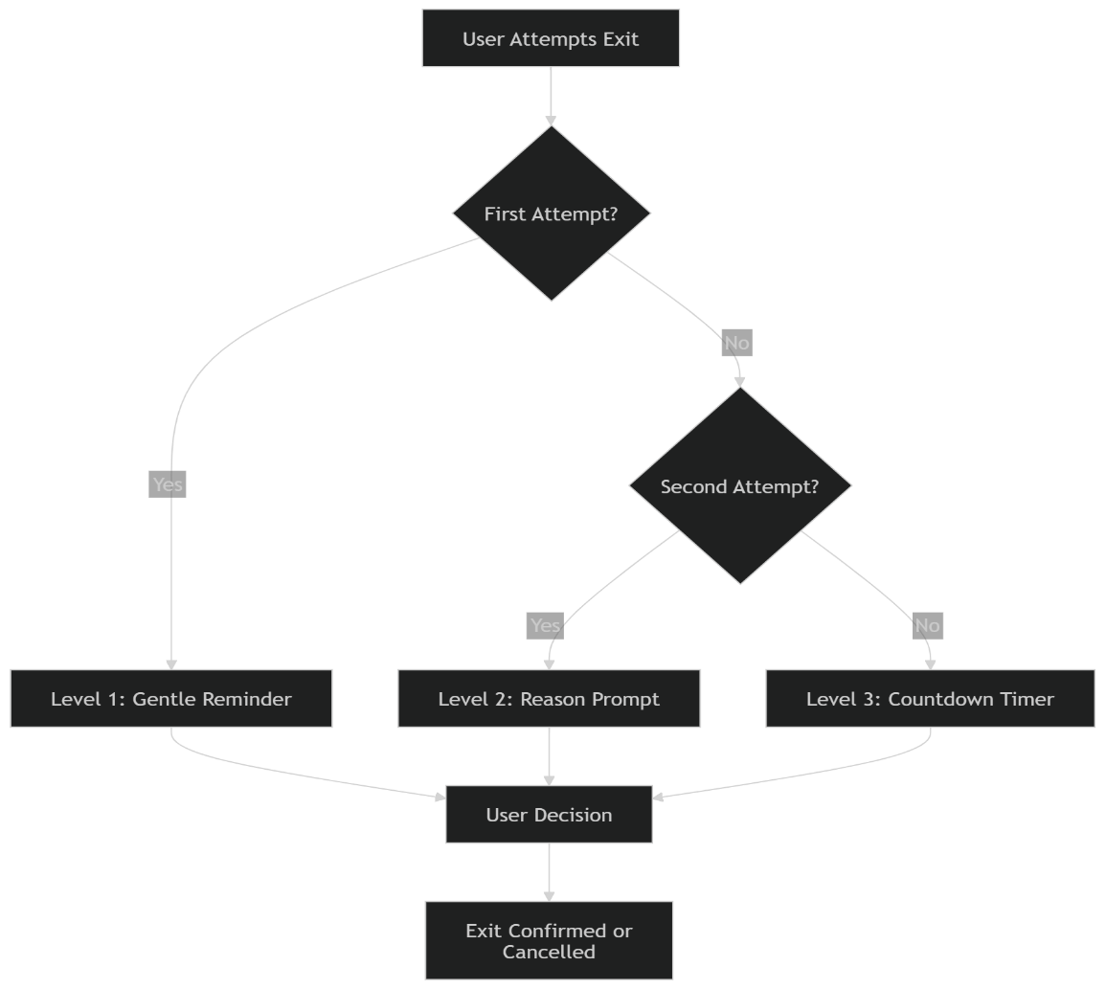
Figure 2.1.4.1 : How adaptive friction works

2.1.5 Human-Centered Interface Design
The system is designed as an overlay interface that activates only when needed. This minimizes disruption and ensures that the user experience remains smooth.
The interface is simple, clear, and responsive, allowing users to quickly understand and respond to system prompts.

2.2 Methodology
The system is designed to detect and manage impulsive exits during study sessions by combining behavioral analysis with real-time intervention.
User interaction data such as session duration and cognitive load is collected and processed by the system. When a user attempts to exit, this data is sent to the backend, where the machine learning model predicts whether the exit is impulsive or genuine.
Based on the prediction, the system dynamically decides the level of intervention to apply. The system continuously logs user actions and responses, enabling future improvements and better personalization.

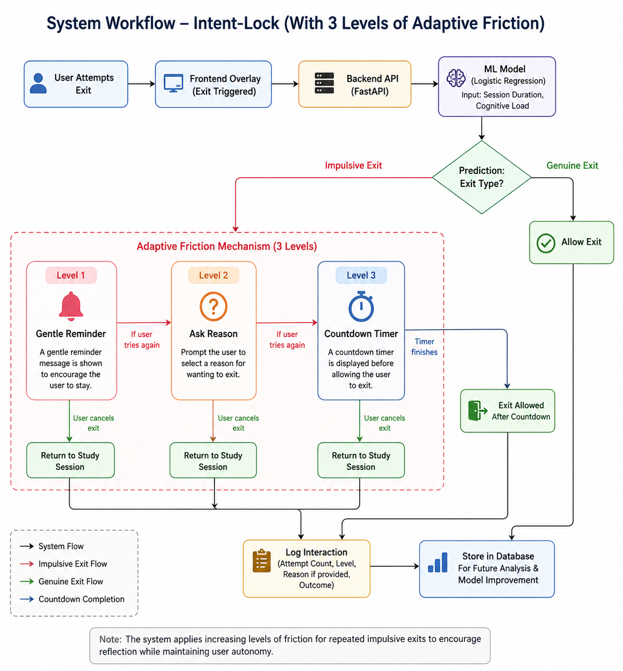
Figure 2.2.1 – Comparison of machine learning approaches for recommendation system

Overall System Description

System Architecture

The system consists of four main components:
- Frontend(Next.js):
Provides the overlay interface for user interaction
- Backend(FastAPI):
Handles data processing and communication
- MachineLearningModel:
Performs exit intent classification
- Database:
Stores user behavior, exit logs, and reasons

The workflow begins when a user attempts to exit a session, triggering a prediction and corresponding intervention.
.

2.2.1.2. Prediction Engine

The prediction engine uses the trained Logistic Regression model to classify exit attempts based on contextual inputs.
The model processes:
- Session duration
- Cognitive load
and outputs a prediction indicating whether the exit is impulsive or genuine.

      - Feedback Loop

User responses, such as exit confirmation and selected reasons, are captured and stored.
This feedback is used to:
- Improve model performance
- Understand user behavior patterns
- Refine intervention strategies

      - User Interface (Overlay System)

The user interface is implemented as an overlay that appears during exit attempts.
It displays:
- Reminder messages
- Reason selection prompts
- Confirmation dialogs
The interface adapts based on the system’s decision.

    - Software Components:

      - Intent Detection Module

Handles prediction of exit intent using the machine learning model.

      - Friction Controller

Determines the level of intervention based on prediction and user behavior history.

      - Backend Implementation

Manages API requests, integrates the model, and handles data storage

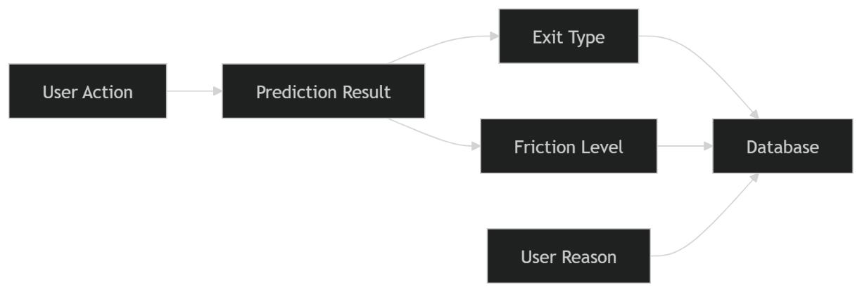

Figure 2.2.2.3.1 – system diagram of software components

    - Model Design and Implementation

      - Logistic Regression for Exit Intent Classification
The primary model used in this system is Logistic Regression, which is applied to classify user exit attempts as either impulsive or genuine. Logistic Regression is a widely used supervised learning algorithm for binary classification problems, where the output is limited to two possible outcomes.
In this system, the model takes a contextual feature vector:
x = [session duration, cognitive load]
where session duration represents the time spent in the study session, and cognitive load (latent mean) represents the user’s mental state. These features are used to estimate the probability that an exit attempt is impulsive.
The model applies a sigmoid function to produce a probability value between 0 and 1:
P(y = 1 | x) = 1 / (1 + e^(-w·x))
where:
- y = 1 represents an impulsive exit
- w represents the learned weights
- x represents the input features
If the probability exceeds a defined threshold, the exit is classified as impulsive; otherwise, it is considered genuine.
Logistic Regression was selected due to its simplicity, interpretability, and efficiency. It performs well with small datasets and allows clear understanding of how input features influence predictions. These properties make it suitable for real-time systems where quick and explainable decisions are required.

      - Synthetic Data-Based Model Training
Since real user data was not available during the initial development phase, a synthetic dataset was generated to train and evaluate the model. Instead of creating random data, the dataset was designed based on established behavioral and cognitive theories to ensure that it reflects realistic study patterns.
The data generation process was guided by Cognitive Load Theory, which suggests that higher mental effort reduces a user’s ability to maintain focus and increases the likelihood of impulsive behavior [3]. Based on this principle, higher cognitive load values were associated with a greater probability of impulsive exits.
In addition, general concepts from attention and user behavior were considered. Users are more likely to abandon tasks early in a session due to distraction or lack of engagement. Therefore, shorter session durations were more likely to be labeled as impulsive exits, while longer sessions were associated with genuine task completion.
Using these assumptions, combinations of session duration and cognitive load were generated and labeled accordingly. For example:
- Short session + high cognitive load → Impulsive
- Long session + low cognitive load → Genuine
This structured approach ensured that the synthetic dataset followed realistic behavioral patterns rather than arbitrary distributions.
The generated dataset was then used to train the Logistic Regression model, allowing it to learn decision boundaries between impulsive and genuine exits. Although synthetic data does not fully capture real-world variability, it provides a strong foundation for initial model development and system testing. Future improvements will involve replacing synthetic data with real user data to enhance model accuracy and reliability.

      - Model Selection and Comparison
During the design phase, multiple modeling approaches were considered, including rule-based systems and more complex machine learning models. Rule-based approaches were found to be too rigid, as they rely on fixed thresholds and cannot adapt to varying user behavior.
More complex models, such as decision trees or ensemble methods, were also considered. However, these models introduce higher computational complexity and require larger datasets for effective training.
Logistic Regression was chosen as the most suitable model due to its balance between performance, simplicity, and interpretability. It provides reliable classification results while maintaining low computational overhead, making it ideal for real-time applications.

2.3.3.4. Model Limitations and Future Improvements
Although Logistic Regression provides a strong baseline, it has certain limitations. The model assumes a linear relationship between input features and the output, which may not fully capture complex behavioral patterns.
In future work, the model can be enhanced by:
- Incorporating additional features such as interaction patterns and time-based behavior
- Using more advanced models such as Random Forest or Neural Networks
- Training with real user data to improve accuracy and generalization
Despite these limitations, the current model is effective for demonstrating the concept of exit intent classification and supports the overall functionality of the system.

    - project Requirements that have been achieved

      - Functional Requirements
  - Real-time detection of user exit attempts during study sessions.

  - Classification of exit intent (impulsive or genuine) using a machine learning model.

  - Application of adaptive friction with three levels: reminder, reason prompt, and countdown.

  - Logging of user actions, predictions, and exit reasons for analysis.

  - Overlay-based interface to deliver system interventions dynamically.

  - Backend API to handle prediction and data storage operations.

      - Non-Functional Requirements

  - Low-latency processing to support real-time predictions and responses.

  - Scalable and modular architecture for future improvements.

  - User-friendly interface with minimal disruption to study sessions.

  - Secure handling and storage of user interaction data.

  - Reliable system performance with consistent prediction behavior.

  - Maintainable design allowing easy updates to model and features.

    - Consideration of the Aspects of the System
Standards:
The system is developed following standard software engineering practices to ensure code quality, maintainability, and scalability. Modular design principles are used to separate components such as the frontend, backend, and machine learning model. Clean coding practices and proper documentation are maintained throughout the implementation. In addition, standard API communication methods and structured data handling are applied to ensure consistency and reliability.
      - Social Aspects
The system is designed to support students in improving focus and productivity during study sessions. By reducing impulsive behavior through adaptive intervention, it encourages better study habits and time management. The system is easy to use and does not require technical knowledge, making it accessible to a wide range of users including students and self-learners.

      - Security Aspects
Basic security measures are implemented to ensure safe handling of user data. All interactions between the frontend and backend are managed through controlled API endpoints. User inputs are validated to prevent incorrect or harmful data processing. Sensitive data is minimized, and stored information is handled securely within the system.

      - Ethical Aspects
The system is designed to respect user autonomy and does not enforce decisions. It provides suggestions through adaptive friction rather than restricting user actions. Only behavioral data related to study sessions is used, and no personal or sensitive information is required. The system acts as a supportive tool, ensuring responsible and ethical use of technology.
    - Limitations
➢ The current model is trained using synthetic data, which may not fully represent real-world user behavior.
➢ The system uses a limited set of input features (session duration and cognitive load), which may not capture all factors influencing user decisions.
➢ The Logistic Regression model assumes a linear relationship between inputs and output, which may not fully reflect complex behavioral patterns.
➢ The system is implemented as a prototype and focuses mainly on core functionality rather than full-scale deployment.
➢ The effectiveness of adaptive friction may vary across different users depending on individual preferences and habits.
➢ The system currently operates on single-user interaction and does not consider collaborative or group-based study environments.

  - Commercialization Aspects of the Product
2.3.1. Target Audience
- Students seeking to improve focus and reduce distractions during study sessions.
- Self-learners and online learners who require structured productivity support.
- Working professionals aiming to manage focus and task completion.
- Educational institutions interested in improving student engagement.

    - Market Space
- Applicable to users across different age groups involved in learning activities
- Can be deployed as a web or desktop-based application
- Requires minimal technical knowledge for usage
- Fits within the growing market of productivity and AI-based learning tools

    - Revenue Earning
- Freemium model with basic features available for free
- Premium features such as advanced insights and personalization
- Institutional licensing for educational organizations
- Potential integration with existing productivity platforms
2.4 Testing & Implementation
Testing and implementation were carried out to ensure that the system functions correctly and provides meaningful user interaction. Each component of the system, including the machine learning model, adaptive friction mechanism, and backend APIs, was tested individually before integrating into the full system.
The prediction model was tested using synthetic data to verify its ability to correctly classify exit attempts. The adaptive friction mechanism was evaluated by simulating multiple exit attempts to ensure that the system correctly progresses through the three levels of intervention: reminder, reason prompt, and countdown.
System performance was also assessed to ensure that predictions are generated with minimal delay, enabling real-time interaction. The frontend interface was tested to confirm that users can easily understand and respond to system prompts.
Basic usability testing was conducted with a small group of users to evaluate ease of use and clarity of the interface. Feedback indicated that the system was intuitive and easy to interact with, though minor improvements in layout and readability were identified.
Overall, the testing and implementation process confirmed that the system operates reliably, provides appropriate interventions, and maintains a smooth user experience.
2.4.1. Exit Intent Classification Model Evaluation
The exit intent classification model was evaluated to assess its ability to correctly identify whether a user’s exit attempt is impulsive or genuine. The model is based on Logistic Regression and uses contextual features such as session duration and cognitive load as input.
Since real user data was not available, evaluation was performed using the synthetic dataset created during the development phase. The dataset includes various combinations of session duration and cognitive load values, representing different study conditions. The model was trained on this dataset and tested to verify its classification performance.
The evaluation focused on the model’s ability to correctly classify:
- Short sessions with high cognitive load as impulsive
- Longer sessions with lower cognitive load as genuine
The results showed that the model was able to learn clear decision boundaries and produce consistent predictions across different input combinations. The simplicity of the model ensured stable performance with low computational overhead, making it suitable for real-time applications.
In addition to classification accuracy, the model was also evaluated in the context of system behavior. The predictions were integrated with the adaptive friction mechanism to ensure that appropriate interventions were triggered based on the output. The system correctly applied reminder, reason prompt, and countdown levels according to repeated impulsive behavior.
Although the evaluation was limited to synthetic data, the results demonstrate that the model provides a reliable baseline for exit intent detection. Future evaluation using real user data will further validate and improve the model’s performance.

2.4.2. Usability Test and Feedback
A preliminary usability test was conducted to evaluate the user interaction and overall experience of the Intent-Lock system. The testing involved a small group of users, including non-technical participants, to ensure that the system is easy to understand and use.
Participants were asked to simulate study sessions and attempt to exit, triggering the system’s adaptive friction mechanism. Key tasks included interacting with reminder messages, selecting exit reasons, and responding to the countdown intervention.
The results indicated that the system was generally intuitive, with users able to understand the purpose of each intervention level. The gradual increase in friction was perceived as helpful rather than restrictive, as it encouraged users to reconsider their actions without forcing them to stay.
Some minor improvements were identified, such as enhancing message clarity and improving visual layout for better readability. These suggestions were incorporated into the system to improve overall usability.
Although the testing was limited in scale, it provided valuable insights into user behavior and system interaction. A larger user study is recommended in future work to further validate usability and effectiveness.

2.4.2. Final Deployment
The final system was deployed as a cross-platform desktop application using Electron, enabling compatibility with Windows, with future plans to extend support for Linux and macOS. The frontend interface for the Intent-Lock component was developed using web technologies and integrated within the Electron framework, providing a responsive overlay-based user experience during study sessions.
The backend components of this module, including the exit intent classification model and adaptive friction logic, were implemented in Python and exposed through RESTful APIs using FastAPI. These APIs handle real-time prediction requests, process contextual inputs such as session duration and cognitive load, and return appropriate responses for intervention.
User interaction data, including exit attempts, prediction results, applied friction levels, and user-provided reasons, were stored using MongoDB. This ensures efficient data management, scalability, and supports future analysis and model improvement. Secure communication between the frontend and backend was maintained through validated API endpoints to ensure data integrity.
The Intent-Lock module was integrated with other system components, particularly the cognitive load module, which provides the latent mean input required for prediction. This integration enables the system to make context-aware decisions based on both behavioral and cognitive factors.
The application was tested across different system configurations to ensure stability, responsiveness, and smooth interaction between components. The adaptive overlay interface was verified to function correctly across various screen sizes and user scenarios.
Overall, the deployment ensures that the Intent-Lock component is scalable, portable, and effectively integrated within the larger system, contributing to improved user focus through intelligent and adaptive intervention mechanisms.

3. RESULT AND DISCUSSION
3.1. Results
3.2. Research Findings
3.3. Discussion
4. CONCLUSION

8 REFERENCES
[1] Cirillo, F. (2006). The Pomodoro Technique. Available at: https://en.wikipedia.org/wiki/Pomodoro_Technique
[2] Hamari, J., Koivisto, J., & Sarsa, H. (2014). Does Gamification Work? — A Literature Review of Empirical Studies on Gamification. Available at: https://ieeexplore.ieee.org/document/6758978
[3] Sweller, J. (1988). Cognitive Load During Problem Solving: Effects on Learning. Cognitive Science. Available at: https://edtechbooks.org/encyclopedia/cognitive_load_theory
[4] Thaler, R. H., & Sunstein, C. R. (2008). Nudge: Improving Decisions About Health, Wealth, and Happiness. Available at:
https://en.wikipedia.org/wiki/Nudge_(book)
[5] Hosmer, D. W., Lemeshow, S., & Sturdivant, R. (2013). Applied Logistic Regression. Available at:
http://books.google.ie/books?id=64JYAwAAQBAJ

